User Guide for Stability Analyzer 53230A
Introduction:
The Stability Analyzer 53230A (2.0) is a free Matlab program that allows you to analyze the stability of clocks, oscillators, and other signal sources using frequency measurements. The program either inputs / uploads frequency measurements from Agilent’s 53230A universal counter or stored measurements on a CSV file. The program provides the user with a choice of two stability calculations, Allan deviation or Hadamard deviation (both overlapping). The program outputs three plots:
- Allan or Hadamard deviation plot with optional confidence intervals.
- Frequency vs time plot of all measurements
- Histogram frequency plot
All plots provide zoom and pan capabilities as well as the ability to identify a particular plot point. The program is setup and run via a graphical user interface (GUI) and is started from the Matlab command line. If the 53230A universal counter is used with the program for making measurements then the Instrument Control toolbox is required in your Matlab package.
Program Settings and Parameters
The following is a detailed description of the measurement, calculation, and instrument parameters and settings on the Stability Analyzer 53230A program. They are covered as they appear from top to bottom and left to right from the GUI (see figure below).
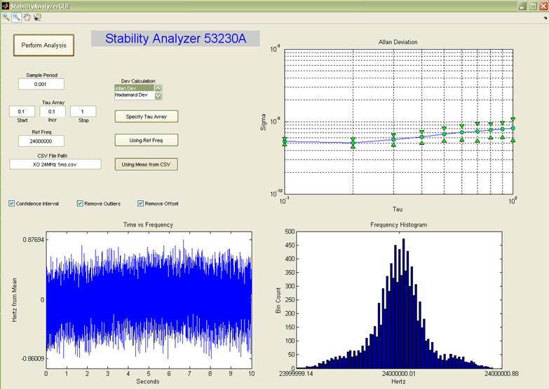

- Perform Analysis button runs the program. Either executes measurements on the 53230A with user settings or fetches them from specified CSV file. It then performs analysis calculations using the measurements and specified user settings.
- Sample Period text box used to specify the sample period on the 53230A frequency counter for th frequency measurements or used to specify the sample period for the measurements on the CSV file. This cannot be left blank.
- Dev Calculation list box allows the user to select the desired stability calculation made, either Allan deviation (overlapping) or Hadamard deviation (overlapping). Allan deviation is the default calculation.
- Tau Array text boxes allow you to specify a list of tau values for the stability calculation. There are two ways to specify the tau values depending on the Tau toggle button (discussed next). The first is to use the Matlab array notation, by specifying a start value, an increment value, and an end value. The second is to upload a CSV file of the desired tau values by entering the CSV file’s name and path into the text box. The tau values in the CSV file should start at row 0 and column 0 and should be in column format.
- Tau toggle button allows you to either use the tau array building option or to upload the values from a CSV. When the button text is “Specify Tau Array” it is in the array building option (state shown in figure and default state). When you press the button and it says “Using Tau CSV” it is in the upload CSV values mode.
- Ref Freq text box where you specify the reference frequency of the clock or oscillator that you are testing. For instance if the oscillator that was measured is 10 MHz you would enter 10e6 into this text box. This is used for doing the stability analysis calculations. This field can be ignored depending on the Ref Freq toggle button (discussed next).
- Ref Freq toggle button used to specify whether the value in the Ref Freq text box is used as the reference frequency or whether the mean of the frequency measurements is used as the reference frequency. When the button text displays “Using Ref Freq” it is using the value in the Ref Freq text box. When pressed and it displays “Using Meas Mean” it is using the mean of the frequency measurements and the Ref Freq text box is ignored.
- 53230A IP Address text box where you specify the LAN IP address of the 53230A you want to connect to and perform the gap-free frequency measurements on the clock you are testing. The program can only connect to the 53230A via LAN. The IP address of the 53230A can be obtained from the 53230A’s “Utility” menu. The position of the Measurement Source toggle button determines whether this setting is used.
- CSV File Path text box where you specify the name and file path of the CSV file containing the frequency measurements you would like to analyze. The measurements should be gap-free or continuous and should start at row 0 and column 0 and be in column format. The position of the Measurement Source toggle button determines whether this setting is used.
- Measurement Source toggle button Used to choose between the 53230A counter or a CSV file as the source of gap-free or continuous frequency measurements to be analyzed. When the text on the button displays “Using 53230A Counter” the measurements will be made with the 53230A (default). When the button displays “Using Meas from CSV” the measurements will be uploaded from a CSV.
- High Z / 50 Ohm toggle button only used when the 53230A counter is being used for the measurements. It specifies the input impedance of the 53230A either 50 Ohm or High impedance (1 MOhm).
- Meas Count text box is used to enter the number of frequency measurements made with the 53230A. It is only used when the 53230A counter is selected as the measurement source.
- Confidence Interval check box when this box is checked the confidence interval of the Allan or Hadamard calculation is shown on the plot. Both the “plus” and “minus” values are shown as green triangles or arrows with the stability calculation in between. If the box is unchecked then just the stability calculations are shown on the plot.
- Remove Outliers check box when this box is checked the measurements are scan for outliers and any outliers found are removed from all plots and calculations. The MADx5 method is used for identifying outliers. When this box is unchecked all readings are used for each plot and calculation.
- Remove Offset check box when this box is checked any offset between the frequency measurements and the reference frequency is removed. If the mean of the measurements is used as the reference frequency then this setting has no effect on the result.
Running the Program
To run the Stability Analyzer 53230A do the following:
- Open Matlab and select the folder the program is in as the “Current Folder.”
- Enter “StabilityAnalyzerGUI;” into the Matlab command line and press enter.
- The Stability Analyzer 53230A GUI will then be launched
- To run the analysis set all desired parameters and settings and press the “Perform Analysis” button.
- An example CSV file with frequency measurements is included in the program folder. The example CSV file entitled “XO 24MHz 1ms.csv” was run in the above example figure in this guide.
The program provides general error detection, error warning messages, and error recovery. It is in no way comprehensive. Errors and exception that occur while running the program will show up in the Matlab command line.
Notes when using the 53230A universal counter:
- The program only connects to the 53230A via LAN / Ethernet. The 53230A’s IP address is needed for connection. To obtain the 53230A’s IP address navigate to the instrument’s “Utility” menu via the front panel.
- The program uses the 53230A’s channel one input for all measurements.
- The trigger level for the signal being measured is mid-point between the max and min amplitude of the signal.
- The program configures the 53230A for continuous or gap-free frequency measurements, which is needed for Allan or Hadamard calculations.
- The max number of readings that can be made by the 53230A is 1M
- The min sample period of the 53230A is 1 us (sample rate 1 MS/s)
- The 53230A’s main accuracy limitation when making stability measurements is the reference timebase used for the measurements. The 53230A comes with either a TCXO or OCXO internal timebase. A higher stability timebase can be substituted by connecting it to the external timebase connector on back the 53230A.
For questions or feedback on the program email neil (underscore) forcier at agilent dot com

